## WORKSHEET

|  |  |
| --- | --- |
| User Name: ……………………………………………. | Trainer Name: Ruchira Ariyasinghe |
| User Sign. : ……………………………………………. | Trainer Sign. : ……………………………………………. |

**WORKSHEET**

**A) Worksheet**

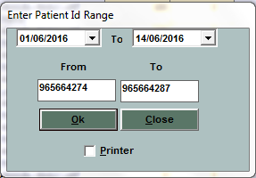

* Enter the From – To patient Id to print worksheet.
* Click on ”Printer” option to print the work sheet

**B) Easy Worksheet**

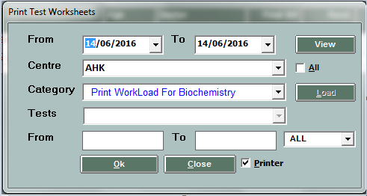

* Select the date.
* Select the main centre and category.
* Click on **Load** button to load the tests.
* From – To numbers will load automatically in textbox
* Click on **Ok** button to see the easy worksheet.
* Click on”Printer” option to take print out.